Real Estate Housing Pricing Predictive Models

Data

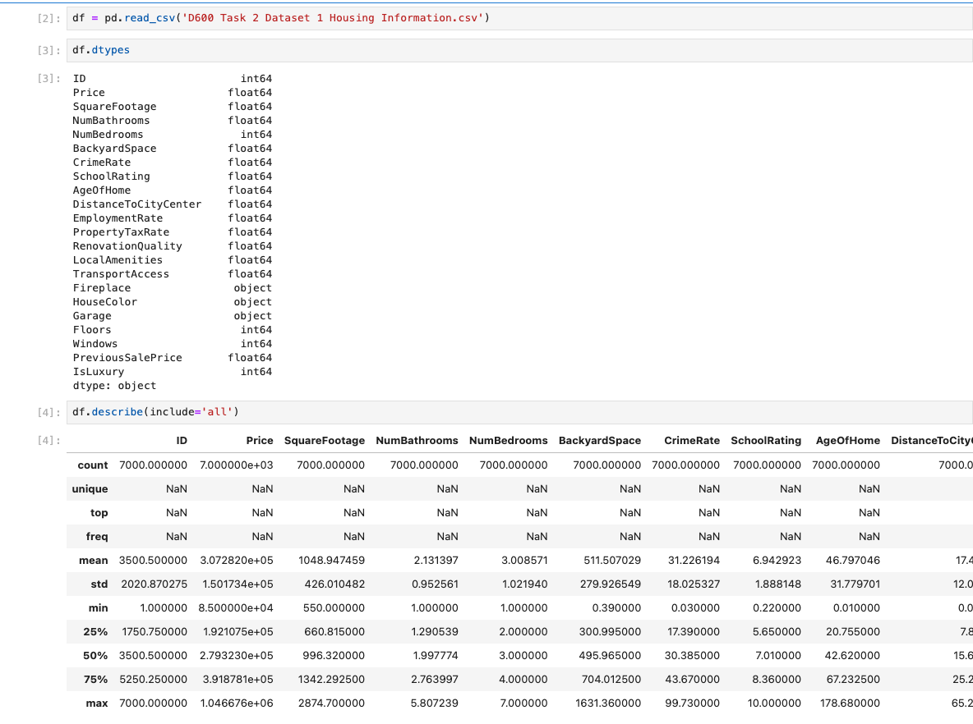C3. Visualizations
Univariate
Square Footage | 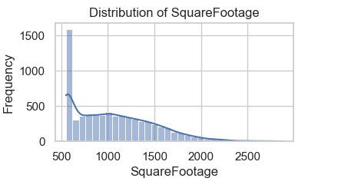
Number of Bathrooms | 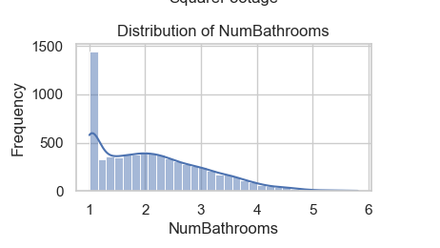
Crime Rate | 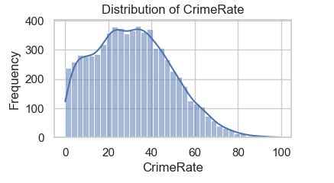
School Rating | 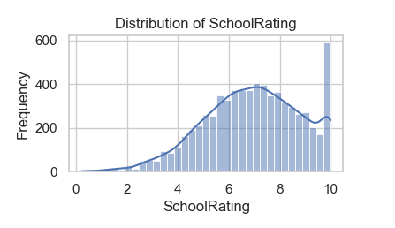
Renovation Quality | 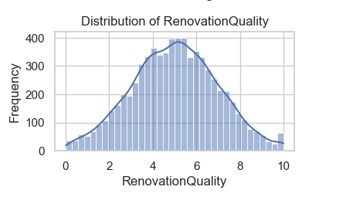
Local Amenities | 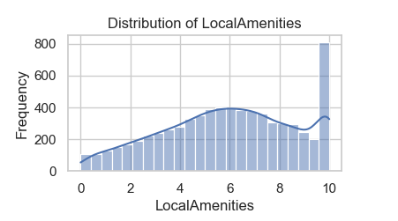
Distance to city center | 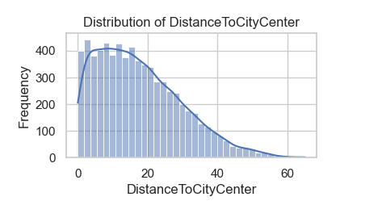
Garage availability | 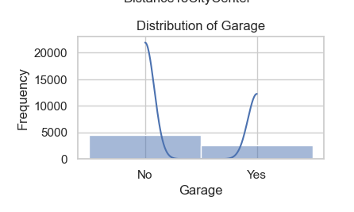
IsLuxury | 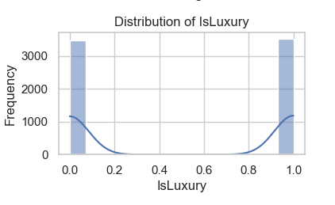

--

Train-Test Split
Split the dataset:
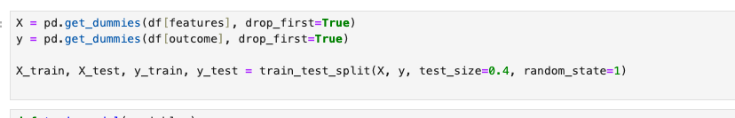
Train-Test Split Ratio:
- Training set: 60% of the data
- Test set: 40% of the data

Build Logistic Regression Model
Use stepwise selection or similar optimization:
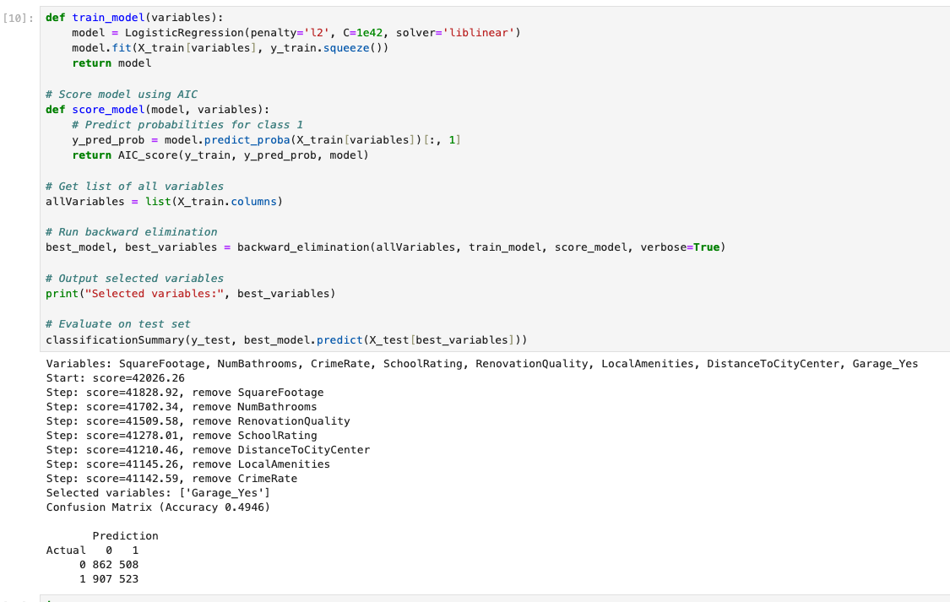

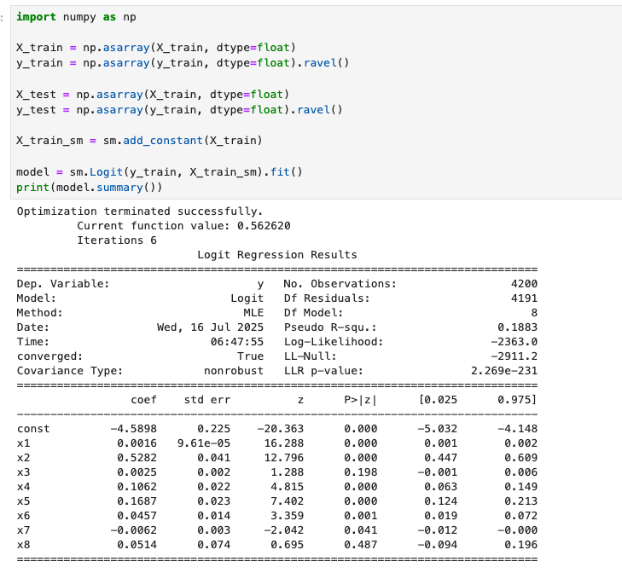
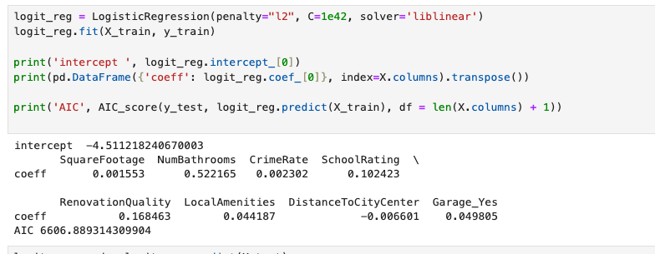

Confusion Matrix & Accuracy on Training Set
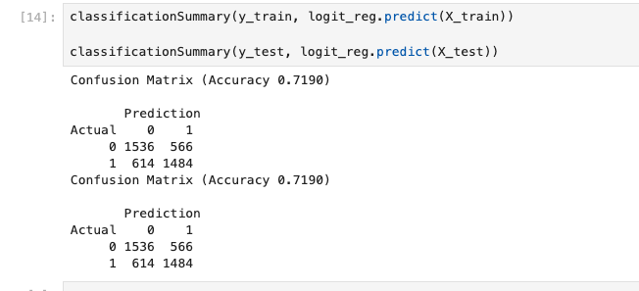

D4. Test Set Prediction
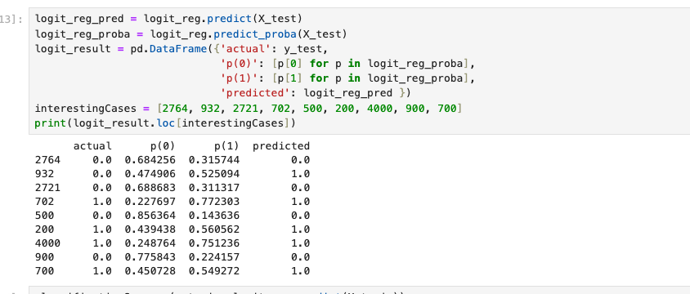

Assumption Checks
Example code to verify multicollinearity:
